|  |  |  |  |  |  |
| --- | --- | --- | --- | --- | --- |
| Date | 24-Nov-22 | | | Tester Name | Mohammad Yusuf |
| Environment | Penfax - Test | | | Login used |  |
| Operating System | Windows | Version: | Update: | | |
| Software Used | Select Software | Version: | Update: | | |
| Select Software | Version: | Update: | | |
| Release version |  | | | | |
| Title |  | | | | |
| Test Type | Regression | | | | |
| Test Scenario |  | | | | |
|  |  | | | | |
| Expected Results |  | | | | |
| Pass/Fail | Select | | | JIRA# | N/A |

Describe your steps with screenshots:

Pre-condition: Login into the application. Find a SPAF member

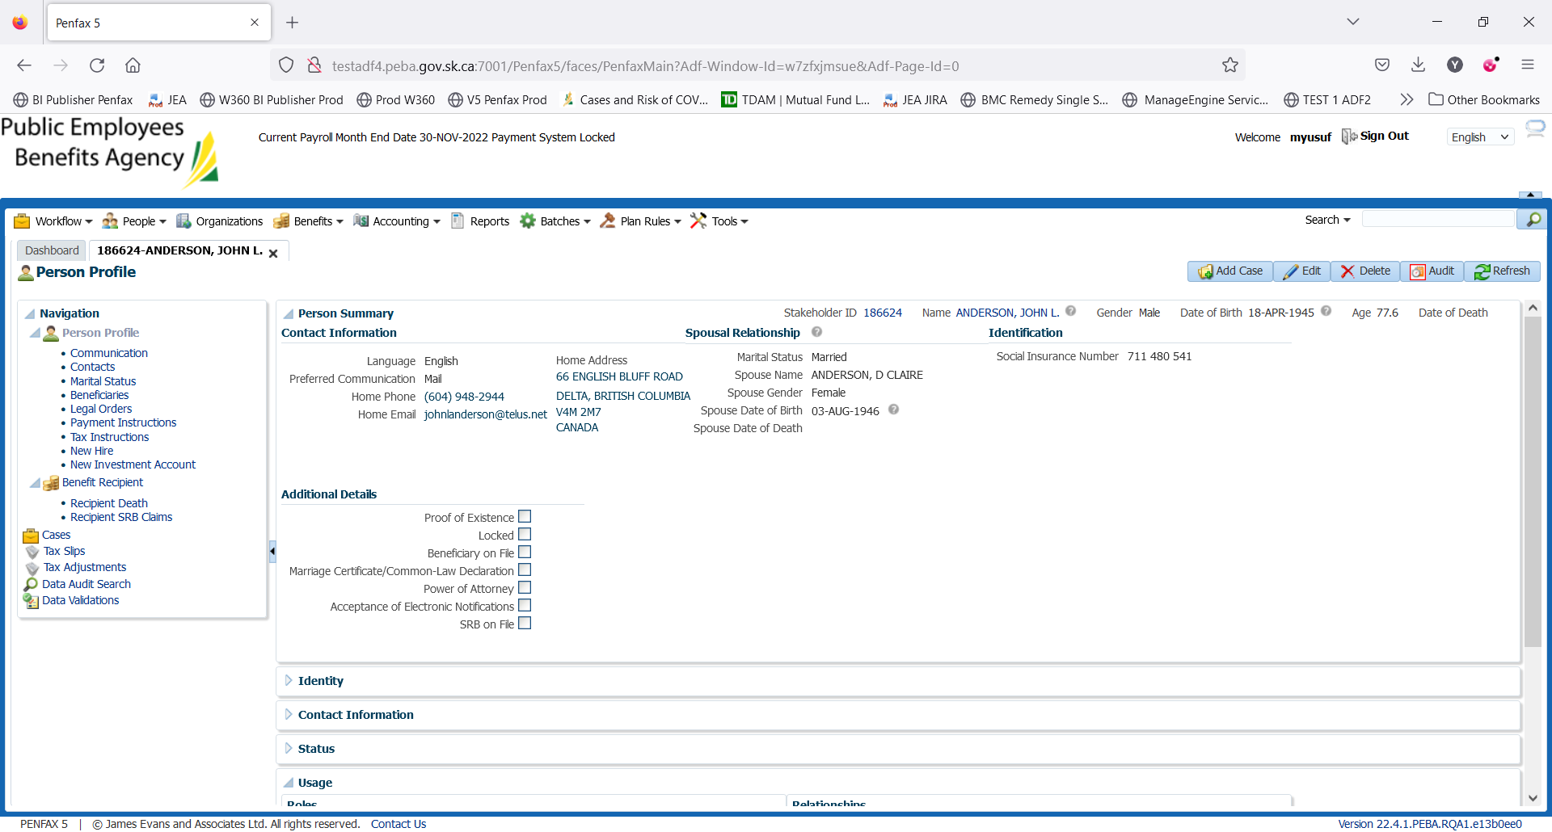

Go to Benefit Recipients -> Deductions

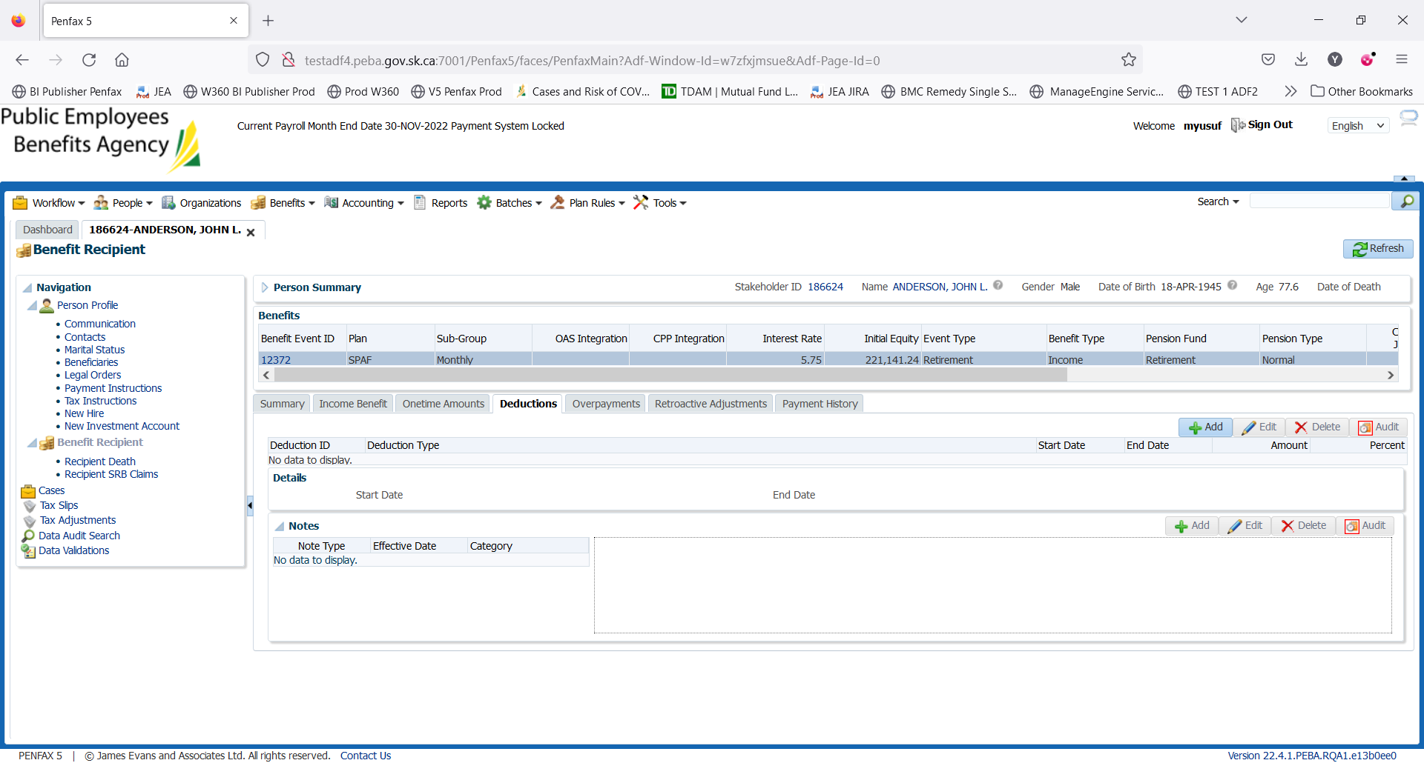

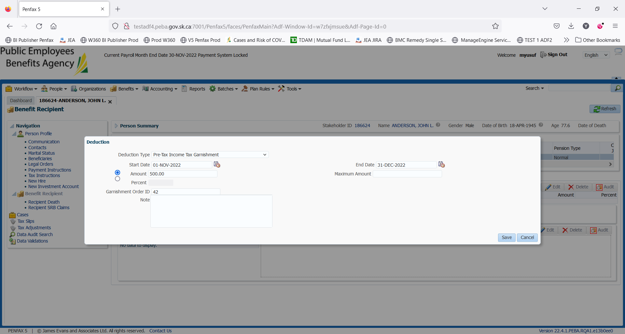

Click on Add

Select the Deduction Type: Generally, MEPP team use

Pre-Tax Income Tax Garnishment &

Pre-Tax Family Law Garnishment

For our test case we will be using Pre-Tax Income Tax Garnishment

Enter the details as selected

The Maximum amount can be 500 or anything. System keeps the track of the deductions till the max. amount.

Click on Save

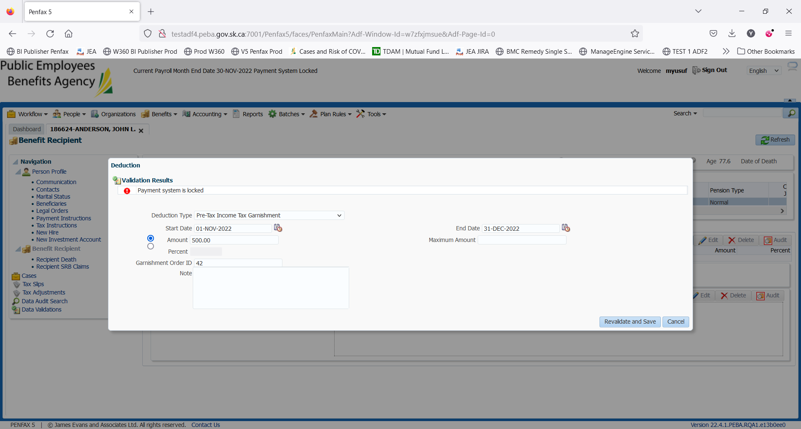

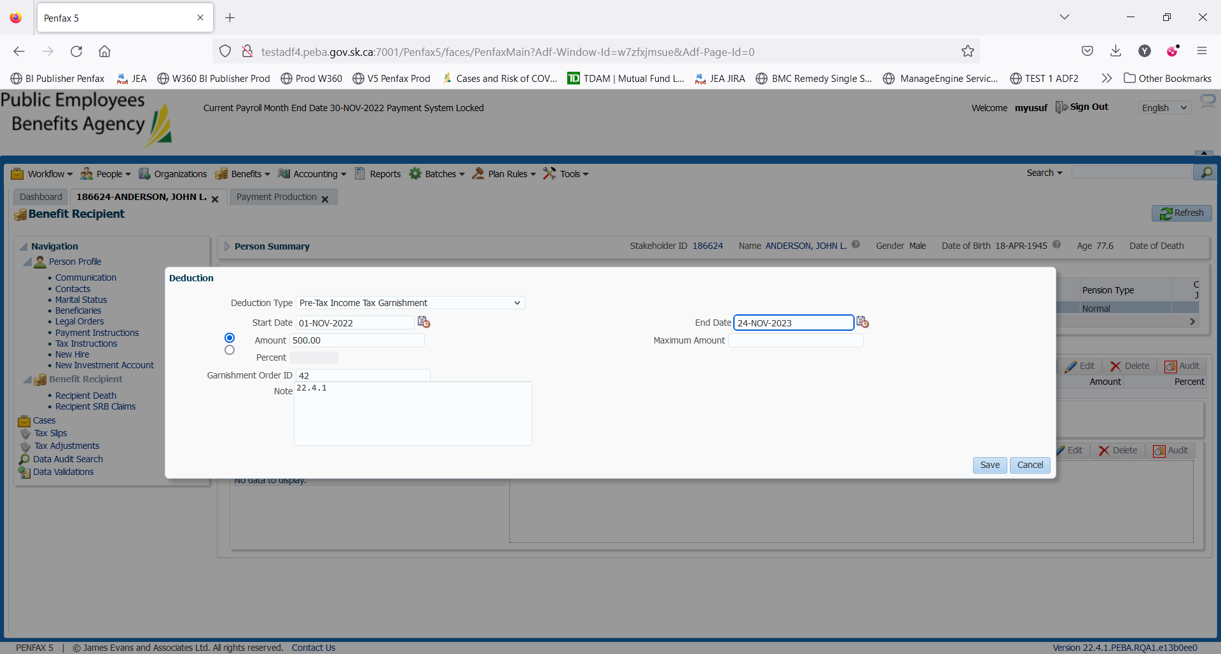

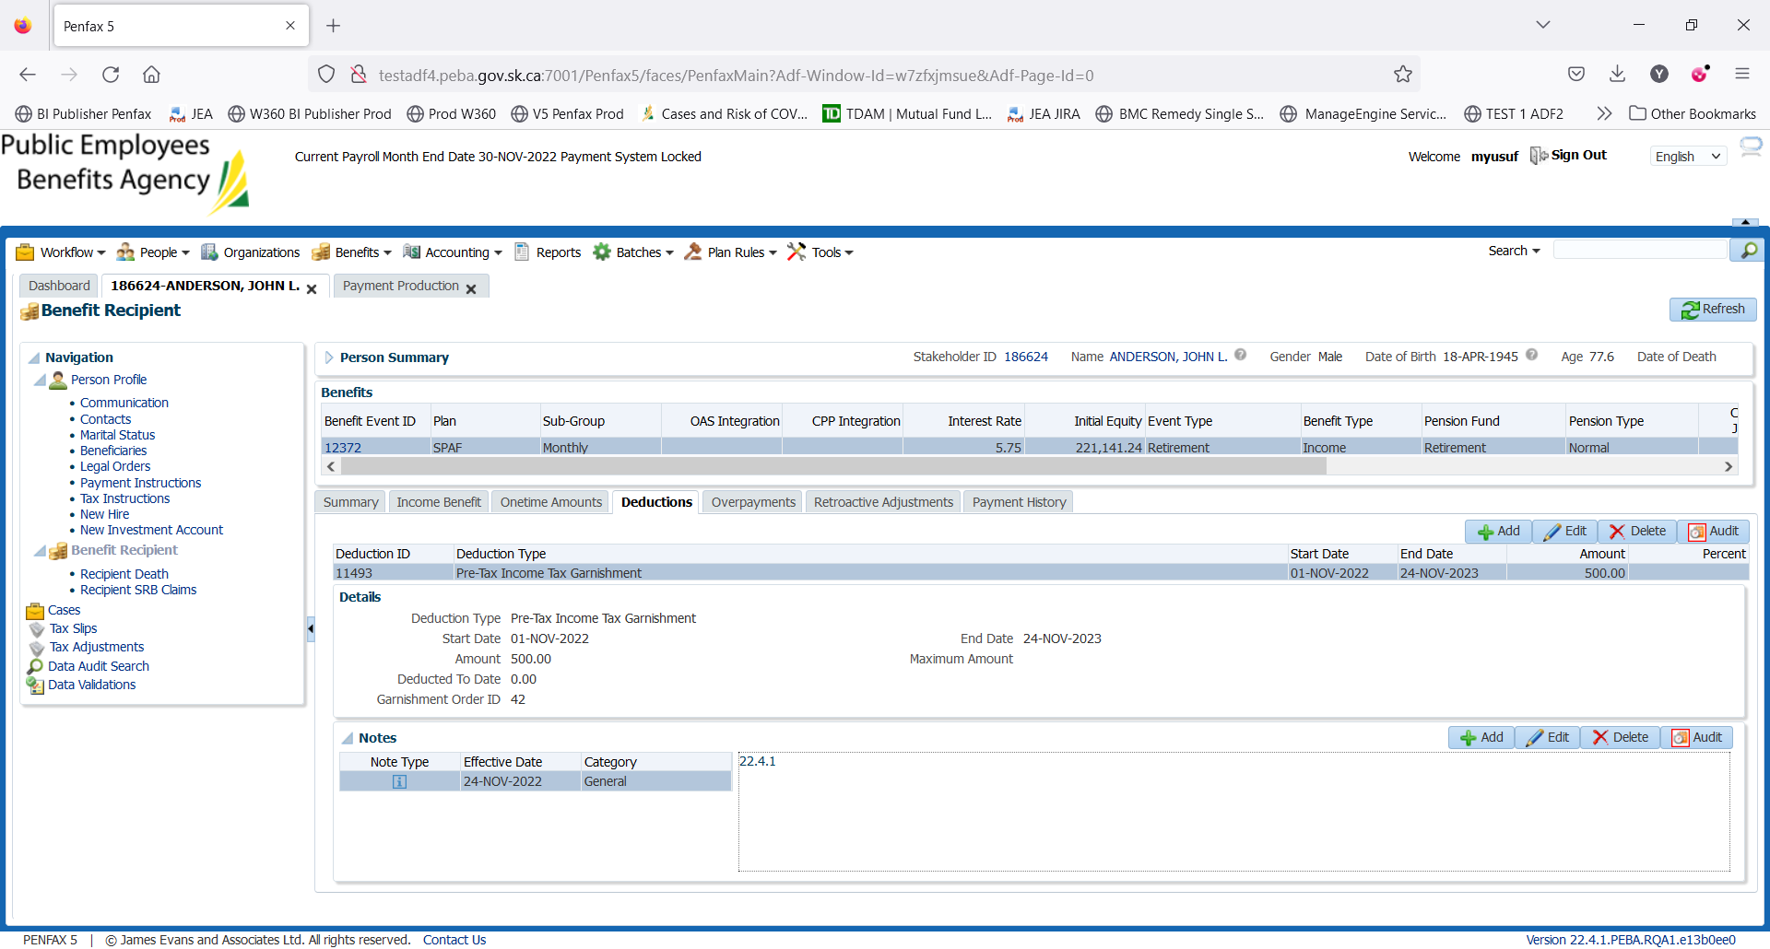

Garnishment total amount was added.

